

LIMITED

LIABILITY COMPANY

**LASERTAG**

SPECIFICATION

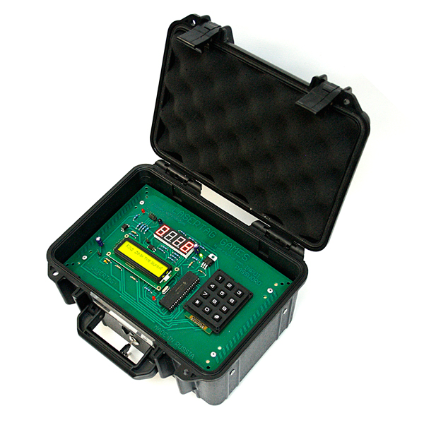

**Game set**

**EXPLOSIVE DEVICE SIMULATOR**

Smolensk

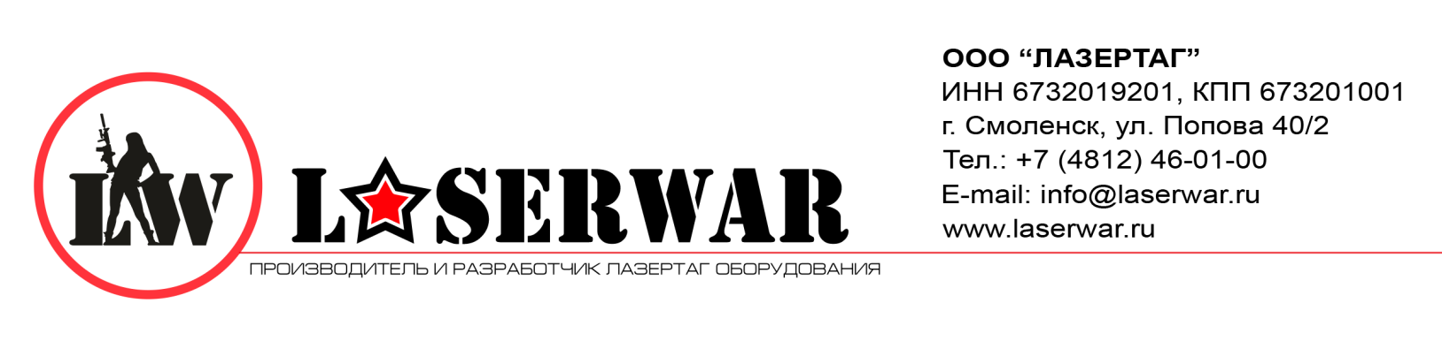

Dear Customer!

Our company welcomes and thanks you for the decision to buy our products, and is confident that the purchased device will bring you a long-term pleasure. The warranty certificate establishes the guarantee of the product in the amount provided for by the Law on consumer protection of the Russian Federation.

This warranty certificate is valid for 12 months from the purchase date of the product, and is subject to the guarantee terms.

Warranty Terms:

1. The guarantee is effective upon presentation of this coupon, which shall contain the serial number of the product and the date of its purchase, confirmed by the service centre.

2. These guarantee obligations apply to products acquired only from the official LASERTAG representative or the official dealer.

3. The present guarantee is invalid if the product deficiencies have occurred in the following cases:

- failure to comply with Operating instructions;

- mechanical damage;

- penetration of extraneous items, liquids, etc.;

- animal activities;

- unauthorized access to the parts of the game set by non-authorized persons;

- use of the product for purposes for which it hasn't been made;

- Acts of elements (natural disaster, fire, accidents, etc.);

- the game set malfunction in case of faulty power network and/or poor care of the product.

4. If the warranty certificate is lost, no duplicate is issued.

**5. Device**

The game set has a black plastic frame.

Inside the frame there are batteries, clamping elements. The frame has a power LED, sound alarm, two information displays, a numeric keypad, a power jack, and a battery charger.

**6. Maintenance**

All parts of the set must be treated with care if you want the equipment to function properly. Protect the IR emitters from mud. There shouldn't be any moisture inside the frame. Charge the battery when needed. Recharge the set using a battery charger (the charger is not included in the set, in should be purchased separately). Don't hit the device.

**7. Changing characteristics**

By default, the admin's password — all 1s, the player's password — all 2s (often the player's password is 12345). If you changed the password and can't remember it, hold "5" when loading the device - the password will be reset. When you turn on the LCD, you will see time information. If you press any key, you will be asked to enter the password.

If you enter an admin password, you will get into the admin mode. If you enter the player's password, the bomb will be activated, the countdown will be displayed on the LED display. The LCD indicator will blink off for some time and then show the "enter the password" menu. If you re-enter the player's password, the countdown will be stopped. If the time is up, the bomb will immediately explode. You will also hear the sound of a siren coming off the speakers. When deactivated/exploded, the device can be used again only after its power down. Your company logo can also be shown on the menu screen (the fourth option in the admin menu).

6

3

The logo can be shown on the bottom line of the display during the system start up.

How it works: Use 2-8 for entering letters, 4-6 for changing the letter's positon, * — apply, # — cancel.

**9. Guarantee obligations**

The manufacturer guarantees the reliability of the operation of an individual LASERWAR set if the consumer has complied with the conditions of use. Technical support is provided within **12 months** of the sale date. The manufacturer undertakes to replace or repair an individual set of equipment free of charge, if the customer has complied with the rules for the device transportation, storage, operation and delivery of defective equipment to Smolensk City.

**9. Contact information**

**Official website:**

www.laserwar.ru

**E-mail:** Purchase Date: _________________________

info@laserwar.ru

support@laserwar.ru

**Skype:**

info-laserwar.ru

support laserwar.ru



______________________________________

**Equipment Maintenance Rules**

***1. Weather conditions.*** At the course of manufacture, we make different tests to see how well the equipment works under different weather conditions. Despite this, we strongly recommend that the equipment shouldn’t be used in the rain and at temperatures below -20 ° C.

What should I know when using the equipment in poor weather conditions?

The most important thing is to avoid getting moisture inside the device. If this happened, turn off the device, dry the equipment at room temperature for at least two hours.

***2. Power source.*** The device uses 12V lead acid batteries.

**To recharge the device use only "Sonar" chargers.**

**Charge the device under supervision for three hours.**

It is necessary to store the equipment in a well-ventilated room at temperature from + 18°C to + 30°C and relative humidity of 45-65%.

**The warranty is 14 days for batteries, speakers, and IR modules. These components are expendable materials.**

**PLEASE NOTE! In the case of improper operation of the accumulator (charging by an unrelated type of a charger), the warranty doesn't cover the battery!**

5

4

**1. Description**

The device is an explosive device simulator that is used for various game scenarios. Use a special key to turn on or reboot the device. All settings are changed in the admin menu. All information is displayed on two screens: a segment display is used for counting time. An LCD display — for entering a password, your club's name, etc.

**2. Scope of application**

The device is designed for laser tag weapons remote control and is used in organizing sporting events, tactical exercises, corporate and recreational activities.

**3. The set includes:**

1. Explosive device simulator - 1 pc.
2. Activation key - 2 pcs.
3. Specification - 1 pc.
4. Charge adapter - 1 pc.

**4. Basic technical Data**

|  |  |
| --- | --- |
| Height, mm | **160** |
| Width, mm | **260** |
| Thickness, mm | **210** |
| Voltage, V | **12** |
| Battery capacity, Ah | **1.2** |
| Number of IR emitters, pc | **1** |
| Wavelength of infrared radiation, nm | **940** |
| Sound volume, dB | **0-120** |
| Weight, kg | **1** |

Information on the repairs performed during the maintenance period (completed by the Service centre performing the warranty repair works).

|  |  |
| --- | --- |
| **Date**: __________________  **Completed work:** _____________________________________________________________________  **Service centre stamp** | **Date**: __________________  **Completed work:** _____________________________________________________________________  **Service centre stamp** |
| **Date**: __________________  **Completed work:** _____________________________________________________________________  **Service centre stamp** | **Date**: __________________  **Completed work:** _____________________________________________________________________  **Service centre stamp** |
| **Date**: __________________  **Completed work:** _____________________________________________________________________  **Service centre stamp** | **Date**: __________________  **Completed work:** _____________________________________________________________________  **Service centre stamp** |

7

2